Emerging Studies Among Family Controlled Firms: A Bibliometric Analysis On Malaysia Listed Companies

Mohd Shazwan Mohd Ariffin¹, Wan Nordin Wan-Hussin²
& Siti Seri Delima Abdul Malak³
¹²Othman Yeop Abdullah Graduate School of Business, Universiti Utara Malaysia, 06010, Sintok, Kedah, Malaysia
³Tunku Intan Shafinaz School of Accounting, Universiti Utara Malaysia, 06010, Sintok, Kedah, Malaysia

ABSTRACT

This study maps and analyses the bibliometric analysis of family-controlled firms among Malaysian listed companies based on observation from article title on September 23, 2020. We examine the timeframe of publication, subject areas, influential affiliation, frequent keywords and the importance of network visualization maps. Thus, influential contributions, university affiliations and research networks are discussed. The review examines 49 documents from 65 subject areas, indexed in the Scopus and Web of Science databases between 2006 and 2020. Interestingly, there is an emerging development of family-controlled firms in general, and the leading scholars strongly interconnected.

Keywords: Family controlled firms, bibliometric, documents, listed companies, databases.

INTRODUCTION

Overview

Family-controlled firms is an emerging and continuous study (Benavides-Velasco, Quintana-García, & Guzmán-Parra, 2013; Cisneros, Ibanescu, Keen, Lobato-Calleros, & Niebla-Zatarain, 2018). Prior studies have indicated utmost of the previous studies associated the family-controlled firms with the organisation or firm (Benavides-Velasco et al., 2013). Therefore, the studies on family-controlled firms was common worldwide. Followed Benavides-Velasco et al., (2013) research, this paper attempts to identified the succession of scholars on the ground of family-controlled firms. This paper intends to observe the family-controlled firms based on two perspectives. Firstly, this paper only focuses family-controlled firms in Malaysia notwithstanding top 100 firm, listed companies or small medium enterprise as long incorporated in Malaysia. Secondly, this paper also only itemized on the Malaysia family-controlled firms based on ownership structure and management control. Previously, a conceptual paper on the family-controlled firms in Malaysia was developed by Hashim, & Ibrahim (2013) based on three-year observation (2007-2009) of 462 Malaysian listed companies under Bursa Malaysia Securities Berhad, followed by a recent systematic literature review among family business consist of 358 articles published related to the topic (Teixeira, Veiga, Figueiredo, Fernandes, Ferreira, & Raposo (2020). Backed with Benavides-Velasco et al., (2013), the intention of this paper specifically on Malaysian family-controlled firms.

Background

This paper examined Malaysia listed companies based on several ground Firstly, almost most of the Asean countries dominated by the family-controlled firms either from ownership or managerial control. Secondly, Malaysia companies compress of unique characteristics for instance listed and non-listed, Main market, Access, Certainty, Efficiency (ACE) market and Leading Entrepreneur Accelerator Platform (LEAP) market governed and monitored by Companies Commission of Malaysia and under regulated of Malaysia Companies Act 2016. Thirdly, Malaysia consist of unique directorships and shareholdings such as Bumiputera (Malaysia, Sabah & Sarawak native) and non-Bumiputera such as Chinese, Indian and foreign residents. Besides, fourthly, Malaysia family-controlled firms mostly in heritage from one generation to another generation (Wan-Hussin, 2009; Mohd-Saleh, & Che Abdul-Rahman, 2009). Fifth and lastly, Malaysia family-controlled firms also associated with the political-tier and government control (Benjamin, Zain, & Wahab, 2016; Tee, 2018) making Malaysia comprehensive with detailed sample for the study.

Hereafter, the rapid studies on the Malaysian family-controlled firms can be seem from the studies by Chu and Cheah (2006), Sivalingam (2008), Mohd-Saleh et al., (2009) on ownership structure, Sang Ong and Gan (2013) on family-owned banks, Goh, Rasli and Khan (2014) on role of non-dominant large shareholders, Ghaleb, Kamardin & Tabash (2020) on ownership concentration and real earnings and so on. As such, current, researchers prefer collaboration with colleagues among scholars, universities and countries to publish together based previous studies. From this perspective, one of the common analysis done to identify the most productive authors and universities among family-controlled firms in Malaysia can be done through bibliometric analysis. Through this analysis, the study used co-authorship analysis to measure cooperation and examines the social networks that have emerged from co-authored articles. Adopted by Cisneros, Ibanescu, Keen et al., (2018), we intend to studies the impact of family-controlled firms in Malaysia using bibliometric analysis.

Research Questions

Each of the research activities come with the common questions (Yoshikane, Nozawa, Shibui & Suzuki, 2009). Therefore, this paper intends to investigate: Which are the most influential authors? Which are the most productive universities? Which are the most important clusters? What are the most important keyword studies by these authors? Where have they been published? related to the family-controlled firms in Malaysia dimensions.

This paper analysed the documents type, year of publications, languages used for publications, subject areas from Scopus and Web of Science databases, followed by network visualization map using VOSviewer and Harzing’s Publish or Perish software for recorded the h-index and g-index, these indicators represent the modern measurement for the quality set of papers (Davis, 2012). Therefore, tools such as VOSviewer and Harzing’s Publish or Perish software as emerging approach to presenting bibliometric analysis material.

The paper structure as below, first the intention of this paper is to evaluate the wide range of literature of emerging studies among family controlled-firms in Malaysia uses a bibliometric analysis. Secondly, the details of the methodology adopted. Thirdly, this section presents the data and methodology used based on bibliometric analysis. Next, the results of the paper present based on the relevant bibliometric indicators. Lastly, the section summaries the findings to identify future research areas and presents some limitations of this paper

LITERATURE REVIEW

Among the emerging trends related to family-controlled firms generally can be seem from studies by Chrisman, Chua and Sharma (2003) titled “Current trends and future directions in family business management studies”. According to this document, family-controlled firms are crucial among scholars on how the firms able to survived and making profits (Chrisman et al., 2003). Interestingly, this document also brings the current topics on the role by family-controlled firms worldwide. According to Chu et al., (2006), the founder family and descendants strongly influence the control of the firm which is known as family-controlled firms. Based Al-Dubai, Ku Ismail and Amran (2014), family-controlled firms can be divided into several parts: (a) portion of capital holding, (b) voting rights, and (c) management position by family members and company control as reported by Villalonga & Amit (2006).

Two-thirds of listed firms in East Asia, including Malaysia, are dominated by family-controlled firms (Husnaini, & Basuki, 2020). Ideally, the family-controlled firms perform better than non-family firms to reduce asymmetry information. Main initiatives of this paper are to explore the emerging studies of family controlled-firm in Malaysian listed. According to Lim, Yuen and Teoh (2019), the majority of family-controlled firms are owned by the Chinese families and the Government, through the investment companies or government linked investment companies (GLIC’s). Indeed, this paper explores the features of family controlled-firm among Malaysian listed companies utilized bibliometric analysis technique.

METHODOLOGY

From the Scopus and Web of Science database, we began the search of keyword “family AND control AND firm”, “family AND ownership” from article title on September 23, 2020. So far, we only focused on mainstream subject of business and management, economic and social science areas from “article” documents type of publication. The main reason of this mainstream subject because we would like to explore the importance of family-controlled firm from listed companies.

After filtering non-open access, specific in the context of Malaysian, these documents consist of three qualitative techniques and forty-six quantitative techniques from both databases. In term of Malaysian listed companies, these studies included firms from Main Market Listing Requirements and Second Market Listing Requirements (ACE) or formerly known as MESDAQ. Figure 1 shows record from the identification through Scopus and Web of Science databases shows that there are 49 documents on family controlled-firms in Malaysia from the period of 2006 to 2020 that in an open access. Since 2006 with the advanced technology, the number of publications also kept growing with minimum at least one document per year except in the year 2007, 2010, 2012 and 2017.

Co-citation analysis and bibliographic coupling were used for the paper data processing. Co-citation play crucial roles for the references or cited documents and consider the stronger relationship if they are cited altogether. Bibliographic coupling, in turn, utilised the influence articles from a given field to others in the same field on the basis of shared references thus suitable for detecting current and future research thus suitable for detecting current and future research trends in accordance with the paper objective (Vogel, & Guttel, 2013).

Utilised PRISMA Flow Diagram (Moher, Liberati, Tetzlaff, Altman, &, Pisma Group, 2009) after reviewing all documents (cited documents), we only focused on the top highly published documents that appropriate to represents the topic of this paper. We, thus decide to include 49 documents in this paper excluded 3 similar documents (in Scopus and Web of Science databases) to answered the research questions. In addition, authorship and institutions also examined in this paper

As mentioned, there are several indicators to use for bibliographic studies. Hence, it encourages more various tools being developed to analyse bibliometric analysis. This paper focused on VOSviewer and Harzing’s Publish or Perish software whereby for VOSviewer, it offers a freely available tool for constructing and visualizing the networks. Besides, it also offers text mining features used to construct and visualize co-occurrence networks of crucial terms extracted from a body of scientific literature. Meanwhile, Harzing’s Publish or Perish software helped researchers to presenting bibliometric analysis material utilised h-index and g-index reporting.

Figure 1: PRISMA Flow Diagram
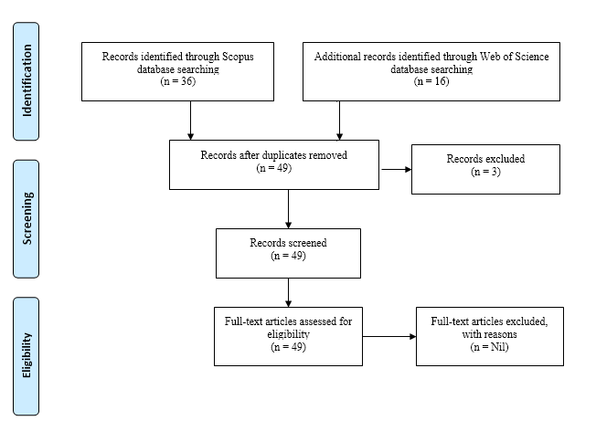

RESULTS AND DISCUSSION

To gain an overview of the research related to family-controlled firms among Malaysia listed companies, some of the general statistics of the data sets are presented. All the documents that met the search query were evaluated from the following aspects: duration of publication, subject areas, most influential affiliation, top 10 most frequent keywords and top 10 less frequent keywords.

Duration of Publication

Table 1: Duration of Publications

Year | Scopus | Web of Science | Total | Percentage
2020 | 4 | 4 | 8 | 16.33
2019 | 7 | 1 | 8 | 16.33
2018 | 6 | 1 | 7 | 14.29
2016 | 0 | 2 | 2 | 4.08
2015 | 5 | 2 | 7 | 14.29
2014 | 5 | 2 | 7 | 14.29
2013 | 3 | 1 | 4 | 8.16
2011 | 3 | 0 | 3 | 6.12
2009 | 1 | 0 | 1 | 2.04
2008 | 1 | 0 | 1 | 2.04
2006 | 1 | 0 | 1 | 2.04
Total | 36 | 13 | 49 | 100.00

The duration of publications represents the initial release of database into both Scopus and Web of Science databases. The Table 1 shows documents initially release in the databases after captured, recorded and analysed using bibliometric analysis. From the analysis, the early adoption of family-controlled firms among Malaysia listed companies started in 2006 (1 document) namely “Does ownership structure matter? Evidence from Malaysian equity market” published by Dr Chu Ei Yet, and Professor Kooi Guan Cheah. According to Google scholar, this article had been cited 32 times published under Corporate Ownership and Control Journal. This is the preliminary document on family controlled-firm in Malaysia studies on 147 firms from Main Market Listing Requirements during 1996 before the regional financial crisis (Chu, & Cheah, 2006). Hence, first and last research question already answered.

In addition, in 2008, Dr. Mageswary Sivalingam wrote an article title “Entry, exit, ownership structure and the Efficient Market Hypothesis: A case study of the Kuala Lumpur Stock Exchange” published under Corporate Ownership and Control Journal. Her research focus on the listed companies dominated by large government owned and family controlled-firms. As highlighted, after the regional financial crisis, it was expected that the stock market involved family conglomerates will improve effectively in the medium and long run (Sivalingam, 2008). Relatively, started in 2009 after the new board structure and new regulatory approaches, number of articles related to family controlled-firm increased over the years. The publication related to family controlled-firm among Malaysian listed companies keeps increased from 3 documents (6.12 percent) to 7 documents (14.29 percent) drastically reduce to 2 documents (4.08 percent) in 2016 and keep increase by 7 documents (14.29 percent) in 2017 onwards.

One possible reason for the reducing because the researchers focusing on the bigger perspective of the family controlled-firms such as ownership structure, ownership concentration and family members on the board that required an extensive study and in 2018, rapidly the number of publications by both databases increase speedily.
Subject Areas

The paper next categorizes the publication based on the subject areas as summarized in Table 2. Utilised the Scopus database, the subject areas dominated by seven main documents consist of Arts and Humanities (9 documents, 13.85 percent), Business, Management and Accounting (21 documents, 32.31 percent), Economics, Econometrics and Finance (18 documents, 27.69 percent), Energy, Engineering and Environmental Science (1 document, 1.54 percent respectively) and Social Sciences with 14 documents (21.54 percent).

Table 2: Subject Areas

Subject Area | Frequency | Percentage
Arts and Humanities | 9 | 13.85
Business, Management and Accounting | 21 | 32.31
Economics, Econometrics and Finance | 18 | 27.69
Energy | 1 | 1.54
Engineering | 1 | 1.54
Environmental Science | 1 | 1.54
Social Sciences | 14 | 21.54
Total | 65 | 100.00

Based on mainstream subject of business and management, economic and social science areas, Business, Management and Accounting and Economics, Econometrics and Finance published more than 15 documents per years. For instance, in 2020, the databases show that the top dominants subject area mainly from Business, Management and Accounting and Economics, Econometrics and Finance. As such, documents (a) Board of directors' characteristics and corporate risk disclosure: the moderating role of family ownership (Alshirah, Rahman, & Mustapa, 2020), (b) Family Ownership and Tax Avoidance: An Analysis of Foreign Related Party Transactions and Dividend Payments (Utama, & Hermawan, 2020), (c) Founder effectiveness in sustaining financial performance: influence of family ownership (Ahmad, Ting, & Le, 2020), (d) Family ownership concentration and real earnings management: Empirical evidence from an emerging market (Ghaleb, Kamardin, & Tabash, 2020), (e) Founder effectiveness in sustaining financial performance: Influence of family ownership (Ahmad et al., 2020) (f) Neighbourhood quality assessment: A view of tenure ownership and mobility decisions in Penang, Malaysia closely specified on family-controlled firms in Malaysia (Fattah, Badarulzaman, & Ali, 2020).

Most influential affiliation with a minimum of three publications

Table 3: Top 5 most influential affiliation with a minimum of three publications

Affiliation | Frequency | Percentage | Cumulative Percentage
Universiti Utara Malaysia | 7 | 31.82 | 31.82
Universiti Sains Malaysia | 5 | 22.73 | 54.55
Universiti Teknologi MARA | 4 | 18.18 | 72.73
Universiti Putra Malaysia | 3 | 13.64 | 86.37
Taylor's University Malaysia | 3 | 13.64 | 100.00
Total | 22 | 100.00

In this paper, we also counted the participation of the institutions related to family controlled-firms (with at least three publications). Firstly, Table 3 shows that in Malaysia, the top 5 publications on this paper dominated by Universiti Utara Malaysia, northern region of Malaysia. Universiti Utara Malaysia is the most productive and influential affiliation according to our study based on the Scopus and Web of Science database in term of minimum three publications.

Secondly, the second highest number of publications on family controlled-firm in Malaysia is Universiti Sains Malaysia also located on the northern region of Malaysia with 5 documents (22.73 percent). Thirdly, Universiti Teknologi MARA produced 4 documents (18.18 percent) publications per year. Meanwhile, both Universiti Putra Malaysia and Taylor’s University Malaysia produce 3 documents with 13.64 percent respectively. Second research question also been well answered.

Top 10 most frequent keyword and top 10 less frequent keyword

This paper also presents the frequency keyword related to family controlled-firm in Malaysia listed companies. The most frequent keyword ranges from 2 to 10 documents per year. As expected, the top 10 frequent keywords consist of family ownership with 10 documents, corporate governance with 8 documents, Malaysia with 6 documents, board independence and family firms both 4 documents respectively followed by firm performance, ownership and ownership concentration with 3 documents respectively. Meanwhile, agency theory and family business reported 2 documents simultaneously.

In contrast, among the less frequent keyword related to this paper consist of expropriation of minority shareholders, family CEO, family firm, family ownership concentration, family related directors, family run business, family-controlled business groups, family-controlled firms, family-controlled publicly-listed firms and financial sustainability with one keyword number of document per year. By that, forth research question also been well answered.

Table 4: Top 10 most frequent keywords and top 10 less frequent keywords

Keyword | Frequency | Keyword | Frequency
Family Ownership | 10 | Expropriation of Minority Shareholders | 1
Corporate Governance | 8 | Family CEO | 1
Malaysia | 6 | Family Firm | 1
Board Independence | 4 | Family Ownership Concentration | 1
Family Firms | 4 | Family Related Directors | 1
Firm Performance | 3 | Family Run Business | 1
Ownership | 3 | Family-controlled Business Groups | 1
Ownership Concentration | 3 | Family-controlled Firms | 1
Agency Theory | 2 | Family-controlled Publicly-listed Firms | 1
Family Business | 2 | Financial Sustainability | 1

Among the documents titled with family ownership keyword in Scopus database such as “Family ownership concentration and real earnings management: Empirical evidence from an emerging market” research by Ghaleb et al., (2020), “Founder effectiveness in sustaining financial performance: Influence of family ownership” published by Ahmad et al., (2020), “How is firm performance related to family ownership in Malaysia and does board independence moderate the relationship?” written by Ng, Ong, Teh, & Soh (2015), followed by “Family ownership heterogeneity and audit committees independence and its implication towards the revised Malaysia code on Corporate Governance” co-authorship by Wan Mohammad, Wan Yusoff, & Nik Salleh (2014).
Further analysis shows that the documents titled with family ownership keyword in Web of Science database such as “Board of directors' characteristics and corporate risk disclosure: the moderating role of family ownership (Alshirah et al., 2020), Family Ownership and Tax Avoidance: An Analysis of Foreign Related Party Transactions and Dividend Payments (Utama et al., 2020), Family ownership concentration and real earnings management: Empirical evidence from an emerging market (Ghaleb et al., 2020) followed by Founder effectiveness in sustaining financial performance: influence of family ownership (Ahmad et al., 2020)”.

Network visualization map based on Scopus and Web of Science database from VOSviewer

Further analysis was utilised mapped using VOSviewer for constructing and visualizing bibliometric networks. The VOSviewer produce colour, square size, font size and thickness of connecting lines were used to present the relationships with other keywords. As such, the keywords with the same colour were commonly listed together as reported by Figure 2 and Figure 3.

Figure 2: Network visualization map on Scopus database from VOSviewer
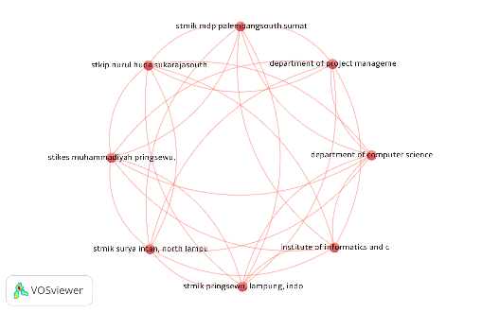
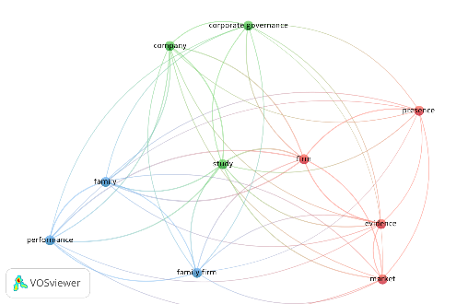

Figure 3: Network visualization map on Web of Science database from VOSviewer
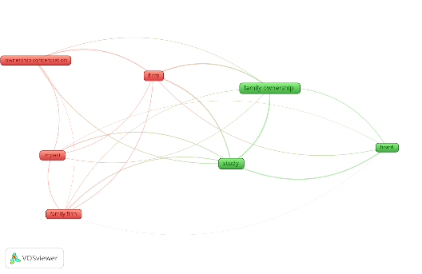
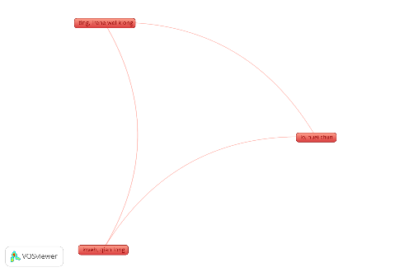

Network visualization map on Scopus database based on title and abstract field (full counting)

This network visualization map on Figure 2 shows that using VOSviewer from title and abstract fields, using full counting method produce minimum number of occurrences of 10 items. From the visualization map, the clusters consist of 3, linked by 45 with total link strength of 1,588. Among the items such as performance (occurrences 46, with relevance of 1.37), firm (occurrences 68, with relevance of 1.35), company (occurrences 33, with relevance of 1.22), family (occurrences 40, with relevance of 1.10), study (occurrences 67, with relevance of 1.07), presence (occurrences 10, with relevance of 1.04), evidence (occurrences 17, with relevance of 0.92), corporate governance (occurrences 19, with relevance of 0.84), family firm (occurrences 22, with relevance of 0.61) and market (occurrences 17, with relevance of 047).

Network visualization map on Scopus database based on co-authorship, unit of analysis organizations (full counting)

The network visualization map based on co-authorship, unit of analysis organizations consist of 1 cluster, 8 items, 28 links. Generally, the higher total link strength is 7 with 20 citations by co-authorship. Only two organizations, College of Business, Universiti Utara Malaysia, Sintok, Kedah, Malaysia and Faculty of Accountancy, Universiti Teknologi Mara, Malaysia produce two documents altogether. The most frequent organization with higher citations consist of faculty of Business And Accountancy, University Of Malaya, Malaysia, Faculty of Economics and Management, Universiti Putra Malaysia, Malaysia, School of Economics, Finance and Banking, Universiti Utara Malaysia, Malaysia, School of Management, Universiti Sains Malaysia, Taylor’s Business School, Taylor’s University, Universiti Kuala Lumpur Business School, Malaysia An Taylor’s Business School, Taylor’s University, Universiti Kuala Lumpur Business School, Malaysia and University College of Technology Sarawak, Malaysia.

Network visualization map on Web of Sciences database based on co-authorship, unit of analysis authors (full counting)

Accordingly, based on Figure 3, network visualization map on Web of Sciences database based on co-authorship, unit of analysis authors shows that the dominants author consists of Ting, Irene Wei Kiong (4 documents with 5 total link strength), followed by Kweh, Qian Long (3 documents with 5 total link strength), Lo, Huai-Chun (2 documents with 4 total link strength) and Kamardin, Hasnah (2 documents with 0 total link strength). Dr. Ting, Irene Wei Kiong was a senior lecturer from Universiti Malaysia Pahang, Malaysia had produced two documents on family-controlled firms in Malaysia such as “Ownership concentration, family ownership and leverage: Evidence from Malaysia (2015)” and “Nonlinear association between ownership concentration and leverage: The role of family control (2016)”.

Network visualization map on Web of Sciences database based on title and abstract field (full counting)

The network visualization map based on title and abstract field shows that seven most frequent term in this network consist of study (occurrences 48, relevance 1.31), board (occurrences 12, relevance 1.29), ownership concentration (occurrences 16, relevance 1.23), family ownership (occurrences 38, relevance 0.87), family firm (occurrences 15, relevance 0.85), firm (occurrences 26, relevance 0.76) and impact (occurrences 14, relevance 0.69). There appeared two clusters with 20 links and total link strength of 718. The term “study” frequently used in the abstract to represent the research overview, thus become dominant keyword in the visualization map analysis. Meanwhile, from Web of Science database, documents titled with term “firm” consist of “Managerial Ownership and Firm Performance: The Influence of Family Directors and Non-Family Directors” published by Associate Professor Kamardin, Hasnah (2014) and “Inside the family firms: The impact of family and institutional ownership on executive remuneration” published by Dr. Ling Jong & Associate Professor Poh-Ling Ho (2018). Therefore, the cluster able to answered the third research question of the paper.

Citation Analysis

Figure 4: Citations Metrics
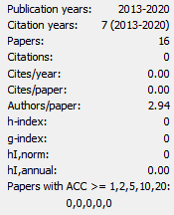
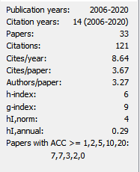

Scopus database Web of Science database
Figure 4 summaries the citation metrics for the retrieved documents from article title on September 23, 2020 using Harzing’s Publish or Perish software that indicated the total publication per years for all retrieved documents, citation years, average h-index and g-index respectively. As shows, most of the researchers prefer to cited from Scopus database instead Web of Science database for the documents on family-controlled firms. From 49 documents observation, there are 121 citations per year reported in 2006 to 2020 with an average of 8.64 cites/year.
CONCLUSION

This paper used a bibliometric analysis to forecast the trends of the family-controlled firms in Malaysia listed companies by not only examined the productivity but also the importance of collaborative networks. The researchers also identified the most influential scholars and most productive clusters using visualization network analysis of co-authorship based on 49 documents from Scopus and Web of Science databases. So far, there is currently limited studies on the family-controlled firms from Malaysia listed companies. The bibliometric analysis provides a good indicator for more exploration study on the family-controlled firms on Malaysia listed companies. The family ownership and family-controlled firms have been increasingly used to measure the attribution toward a good governance. It is encouraging nevertheless, to more studies from mainstream subject of business and management, economic and social science areas to study on family-controlled firms. In the nutshell, we need to obtain a better understanding of the main determinants for family-controlled firms among Malaysia listed companies. In conclusion, it appears that the documents on the family-controlled firms is on the emerging development for the Malaysia studies.

REFERENCES

Ahmad, N., Ting, I. W. K., & Le, H. T. M. (2020). Founder effectiveness in sustaining financial performance: influence of family ownership. Journal for International Business and Entrepreneurship Development, 12(2-3), 109-121.
https://doi.org/10.1504/JIBED.2020.106174
Al-Dubai, S., Ku Ismail, K. N. I., & Amran, N. A. (2014). Family business definition: A matter of concern or a matter of convenience?. Corporate Ownership and Control, 11(2).
Alshirah, M. H., Rahman, A. A., & Mustapa, I. R. (2020). Board of directors' characteristics and corporate risk disclosure: the moderating role of family ownership. EuroMed Journal of Business. https://doi.org/10.1108/EMJB-09-2019-0115.
Benavides-Velasco, C. A., Quintana-García, C., & Guzmán-Parra, V. F. (2013). Trends in family business research. Small Business Economics, 40(1), 41- 57. https://doi.org/10.1007/s11187-011-9362-3.
Benjamin, S. J., Zain, M. M., & Wahab, E. A. A. (2016). Political connections, institutional investors and dividend payouts in Malaysia. Pacific Accounting Review. https://doi.org/10.1108/PAR-06-2015-0023.
Chrisman, J. J., Chua, J. H., & Sharma, P. (2003). Current trends and future directions in family business management studies: Toward a theory of the family firm. Coleman white paper series, 4(1), 1-63.
Chu, E. Y., & Cheah, K. G. (2006). Does ownership structure matter? Evidence from Malaysian equity market. Corporate Ownership and Control, 4(1), 77-90.
Cisneros, L., Ibanescu, M., Keen, C., Lobato-Calleros, O., & Niebla-Zatarain, J. (2018). Bibliometric study of family business succession between 1939 and 2017: mapping and analysing authors’ networks. Scientometrics, 117(2), 919-951.
Davis, P. (2012). The emergence of a citation cartel. The Scholarly Kitchen, 10, 15-17.
Fattah, H. A., Badarulzaman, N., & Ali, K. (2020). Neighbourhood Quality Assessment: A View of Tenure Ownership and Mobility Decisions in Penang, Malaysia. Planning Malaysia, 18(11).
http://dx.doi.org/10.21837/pm.v18i11.712
Ghaleb, B. A. A., Kamardin, H., & Tabash, M. I. (2020). Family ownership concentration and real earnings management: Empirical evidence from an emerging market. Cogent Economics & Finance, 8(1), 1751488. https://doi.org/10.1080/23322039.2020.1751488
Goh, C. F., Rasli, A., & Khan, S. U. R. (2014). Economic incentives for family controlling shareholders and the monitoring role of non-dominant large shareholders in corporate governance: Evidence from the manufacturing firms in Malaysia. South African Journal of Economic and Management Sciences, 17(4), 471-483.
Hashim, H. A., & Ibrahim, H. (2013). The Board of directors in family controlled firms. World Applied Sciences Journal, 28(11), 1597-1604. https://doi.org/10.1108/edi-02-2019-0084.
Husnaini, W., & Basuki, B. (2020). ASEAN Corporate Governance Scorecard: Sustainability Reporting and Firm Value. The Journal of Asian Finance, Economics,and Business, 7(11), 315-326.
https://doi.org/10.13106/jafeb.2020.vol7.no11.315
Jong, L., & Ho, P. L. (2018). Inside the family firms: The impact of family and institutional ownership on executive remuneration. Cogent Economics & Finance, 6(1), 1432095. https://doi.org/10.1080/23322039.2018.1432095
Kamardin, H. (2014). Managerial ownership and firm performance: The influence of family directors and non-family directors. Ethics, Governance and Corporate Crime: Challenges and Consequences, 6, 47- 83.
Lean, H. H., Ting, I. W. K., & Kweh, Q. L. (2015). Ownership concentration, family ownership and leverage: Evidence from Malaysia. Malaysian Journal of Economic Studies, 52(2), 117-133.
Lim, K. P., Lye, C.-T., Yuen, Y. Y., & Teoh, W. M. Y. (2019). Women directors and performance: evidence from Malaysia. Equality, Diversity and Inclusion: An International Journal, 38(8), 841–856. https://doi.org/10.1108/EDI-02-2019-0084
Lo, H. C., Ting, I. W. K., Kweh, Q. L., & Yang, M. J. (2016). Nonlinear association between ownership concentration and leverage: The role of family control. International Review of Financial Analysis, 46, 113-123.
https://doi.org/10.1016/j.irfa.2016.04.013
Mohammad, W. M. W., Yusoff, W. F. W., & Nik, N. M. Z. Family ownership heterogeneity and audit committees independence and its implication towards the revised Malaysia code on corporate governance (MCCG, 2007). Corporate Ownership & Control, 456.
Mohd-Saleh, N., & Che Abdul Rahman, M. R. (2009). Ownership structure and intellectual capital performance in Malaysia. Asian Academy of Management Journal of Accounting and Finance, 5(1), 1-29.
Moher, D., Liberati, A., Tetzlaff, J., Altman, D. G., & Prisma Group. (2009). Preferred reporting items for systematic reviews and meta-analyses: the PRISMA statement. PLoS med, 6(7), e1000097. https://doi.org/10.1371/journal.pmed.1000097
Ng, S. H., Ong, T. S., Teh, B. H., & Soh, W. N. (2015). How is firm performance related to family ownership in Malaysia and does board independence moderate the relationship. Corporate Board: Role, Dufies, and Composifion, 11(2), 21-35.
Raposo, M. (2020). A systematic literature review on family business: insights from an Asian context. Journal of Family Business Management. https://doi.org/10.1108/JFBM-12-2019-0078
San Ong, T., & Gan, S. S. (2013). Do family-owned banks perform better? A study of Malaysian banking industry. Asian Social Science, 9(7), 124.
Sivalingam, G. (2008). Entry, exit, ownership structure and the efficient market hypothesis: A case study of the Kuala Lumpur Stock Exchange. Corporate Ownership & Control, 315.
Tee, C. M. (2018). Family firms, political connections and audit fees: evidence from Malaysian firms. Managerial Auditing Journal. https://doi.org/10.1108/MAJ-06-2017-1585
Teixeira, S., Veiga, P. M., Figueiredo, R., Fernandes, C., Ferreira, J. J., &
Utama, S., & Hermawan, A. A. (2020). Family Ownership and Tax Avoidance: An Analysis of Foreign Related Party Transactions and Dividend Payments. International Journal of Business & Society, 21(2).
Villalonga, B., & Amit, R. (2009). How are US family firms controlled? The Review of Financial Studies, 22(8), 3047-3091. https://doi.org/10.1093/rfs/hhn080
Vogel, R., & Güttel, W. H. (2013). The dynamic capability view in strategic management: A bibliometric review. International Journal of Management Reviews, 15(4), 426-446.
https://doi.org/10.1111/ijmr.12000.
Wan-Hussin, W. N. (2009). The impact of family-firm structure and board composition on corporate transparency: Evidence based on segment disclosures in Malaysia. The International Journal of Accounting, 44(4), 313-333. https://doi.org/10.1016/j.intacc.2009.09.003.
Yoshikane, F., Nozawa, T., Shibui, S., & Suzuki, T. (2009). An analysis of the connection between researchers’ productivity and their co-authors’ past attributions, including the importance in collaboration networks. Scientometrics, 79(2), 435-449.

https://harzing.com/resources/publish-or-perish.
http://prisma-statement.org/prismastatement/flowdiagram.aspx.
https://www.bursamalaysia.com/sites.

