Constructing Stock Market Performance Index for ASEAN 5 Countries: Principal Component Analysis Approach
Kelvin Lee Yong Ming, Mohamad bin Jais
Universiti Malaysia Sarawak
ABSTRACT
This study develops the stock market performance index (SMPI) for ASEAN-5 countries, which include Indonesia, Malaysia, Thailand, Philippines, and Singapore. Along with that, principal component analysis is applied in developing the index. Annual data of ASEAN-5 countries ranging from the year 2000-2016 has been used for the purpose of analysis. The sources of data are the World Bank Database and Datastream. The results indicate that Singapore has the highest SMPI over the sample period, while Indonesia has the lowest SMPI over the sample period 2000 to 2016.
Keywords: Stock Market, Stock Market Performance Index
1.0 INTRODUCTION
Stock market acts as a platform where stocks are bought and sold by investors. By linking the surplus and deficit sector of the market, the stock market plays a significant role in helping a nation’s monetary advancement (Nasser, Rosid & Baharuddi, 2017). Also, the stock market helps in facilitating economic growth by increasing the liquidity of financial assets and making risk diversification possible (Osei, 2005). A stock market index is usually used to reflect the stock market performance. As mentioned by Dai, Han and Dai (2014), stock market indexes were usually used by the investor as the reference for their investment strategies. In addition, stock market indexes are crucial to macroeconomists and financial economist since it helps them to understand the behavior of market participants, the evolution of the economy and making the international comparison possible (Hautcoeur, 2006).
The capitalization-weighted index method is usually used to compute the current stock market index (Menon, 2018). Noteworthy, all the stock indexes from the ASEAN-5 countries were capitalization-weighted index. However, captalization-weighted index tend to suffers from methodlogical issue due to the reason that the price movements of the large firm stocks act as the main driving force for the stock indexes movements (Pan & Mishra, 2016). Nevertheless, Hautcoeur (2006) argued that there is a small number of discussions related to methodology for indices were conducted previously. Stock market indices should not be the only reference for investors to evaluate the stock market performance since it only reflects the movement of a specific number of stocks. However, stock market performance can be measured by different aspect, such as stock market liquidity, stock market volatility and stock market development.
By using principal component analysis, this study attempts to develop the stock market performance index (SMPI) for ASEAN-5 countries which able to capture the stock market performance from four different aspects: (i) stock market returns; (ii) stock market volatility, (iii) stock market liquidity; and (iv) stock market development. The remainder of this paper is organized as follows, section 1.1 briefly discusses about the Association of Southeast Asian Nations (ASEAN). Section 2 discusses about the related previous literature. Section 3 presents the methodology to be used in this study. Section 4 provides empirical findings and discussion. Concluding remarks and implications of study are presented in the last section.
1.1 Association of Southeast Asian Nations (ASEAN)
The sample countries to be included in this study were ASEAN-5 countries, which included Indonesia, Malaysia, Philippines, Singapore, and Thailand. In 1967, Association of Southeast Asian Nations (ASEAN) was established in Bangkok with the five original countries: Indonesia, Malaysia, Philippines, Singapore and Thailand. Currently, ASEAN consisted of ten countries - Indonesia, Malaysia, Philippines, Singapore, Thailand, Brunei Darussalam, Vietnam, Laos, Myanmar, and Cambodia. (Yamamoto, 2012). As depicted in Figure 1, the combined GDP of ASEAN-5 countries had increased from $572.74 billion in the year 2000 to $2,237.7 billion in the year 2016. On the other hand, the real GDP growth of ASEAN is expected to be maintained at an average growth rate of 6.2% over the year 2017-2021 (OECD, 2017). Besides that, Yamamoto (2012) also mentioned that ASEAN had attracted worldwide attention since ASEAN countries able to recover rapidly from the 2008 global financial crisis.
Figure 1: Combined Gross Domestic Product (GDP) of ASEAN-5 Countries
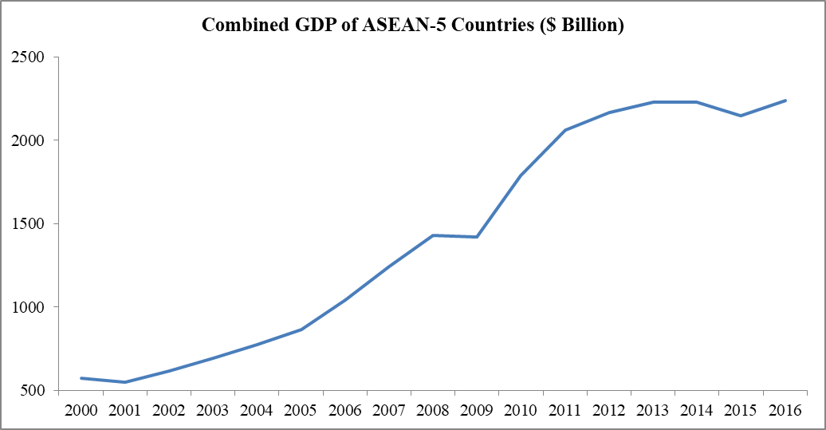
Sources: World Development Indicator

2.0 LITERATURE REVIEW
Over the past decade, numerous studies had been conducted to develop various types of indices (for instances, financial stress index, financial inclusion index and financial stability index) to be used as the measurement for financial system performance (Morales & Estrada, 2010; Yorulmaz, 2013; Karanovic & Karanovic, 2015; Dahalan, Abdullah & Umar, 2016). However, there is lack of previous studies that focus solely in constructing the index to capture the stock market performance from different aspects. This study shed up the light by combining the four different variables that related to stock market performance, into a singular index.
One of the pioneering works related to the index construction had been conducted by Levine and Demirguc-Kunt (1995). By using three indicators - market capitalization ratio, total value traded to GDP ratio and turnover ratio, they constructed an aggregate index which able to reflect the stock market development level of a country. By using principal component analysis, Ang and McKibbin (2007) created the proxy to reflect the development of Malaysian financial sector. Four different models were developed, where each model consists of per capita real GDP, financial depth proxy and a conditioning variable (the conditioning variable could be saving, investment, real interest rate or trade openness). The findings indicated that Malaysia financial system had been enlarged by the financial sector reforms, but they also found that this policy does not lead Malaysia to have the higher long-run growth.
Using the data from year 1980 to 2012, Badeeb and Lean (2017) applied principal component analysis to construct the new proxy for the financial development in the Republic of Yemen. In order to capture the financial development from different dimensions, three indicators which were (i) M2 as the proportion of GDP; (ii) domestic credit to the private sector as the proportion of GDP; and (iii) size of the deposits relative to GDP had been included in the construction for the new proxy. The researchers also revealed that trade openness affect the financial development of Republic of Yemen positively, while the natural resource dependence affects the financial development negatively. However, inflation does not shown a significant effect towards the new measure of financial development.
By using principal component analysis, Chen and Woo (2010) constructed a composite index in measuring the economic integration in the Asia-Pacific region. Two-stage principal component analysis was used to obtain the weights for the index. Firstly, a convergence index was obtained based on the main macroeconomic indicators of the Asia Pacific countries. Secondly, the convergence index, indicators of foreign direct investment (FDI), trade and tourism are used to compute the weightage for the composite index. Based on the panel data of 17 Asia Pacific countries covered the period 1990 to 2006, the researchers found that Singapore, Hong Kong and Chinese Taipei are the most integrated with the Asia Pacific region whereas Indonesia and China are the least integrated with Asia Pacific region.
In the context of Indian stock market, Kumar (2013) extracted three factors – namely macro environment, industrial performance and policy rates by using the factor analysis approach. These three factors were used to explain the variation among the 12 macroeconomic variables. Thereafter, the researcher tested the relationship between these factors with the Indian stock market and revealed that macro environment and industrial performance had the significant role in influencing the Indian stock market. In contrast, there is no significant result to support the impact of policy rates towards the Indian stock market.
Following the methodology used by the Chen and Woo (2010), principal component analysis is applied to construct the stock market performance index (SMPI). Meanwhile, stock market liquidity is included in the construction of index since stock market liquidity is an important dimension of financial system stability (Soedarmono, 2018). Following the global financial crisis, Hameed, Kang and Viswanathan (2010) stated that the panic selling of market participants and liquidity constraints of financial intermediaries contributed to the dry up of stock market liquidity and then led to financial market upheaval.

3.0 DATA AND METHODOLOGY
The stock market performance index (SMPI) is developed using principal component analysis discussed in the previous studies. The samples countries included in this study were Indonesia, Malaysia, Philippines, Singapore and Thailand. Along with that, five stock exchanges included in this study are Jakarta Stock Exchange Composite Index (JCI), Kuala Lumpur Composite Index (KLCI), Philippines Stock Exchange Index (PSEI), Straits Times Index (STI) and Stock Exchange of Thailand (SET). The data employed in this study consisted of the annual data covered the period from year 2000 to 2016. The annual data had been downloaded from the World Bank Database.
3.1 Weightage Allocation
SMPI is developed in order to capture the stock performance from different aspects. Thus, four different variables are used to represent (i) stock market returns; (ii) stock market volatility, (iii) stock market liquidity; and (iv) stock market development respectively. Table 1 describes the variables that included in the SMPI construction.
Table 1: Summary of Variables Used in the Index Construction
Variables | Description | Source
Stock Market Returns | Percentage changes in the stock market index | World Bank Database
Stock Market Volatility | Standard deviation of the stock market index returns | World Bank Database
Stock Market Liquidity | Value of stocks traded as a percentage of GDP | World Bank Database
Stock Market Development | Market capitalization of domestic listed companies as a percentage of GDP | World Bank Database
Weights allocation is crucial in the process of constructing a composite index. Reasonable weights need to be assigned for the chosen variables in order to let the composite index to capture the information from various dataset (Chen and Woo, 2010). Thus, this study applied the parametric method - Principle Component Analysis (PCA) in order to determine the weight for the four variables. Following Chen and Woo (2010), the weight is calculated based on the steps as follows:
- Principal component analysis is used to determine factor loading and eigenvalue for the four principle components.
- Next, for each variable, determine the product of the factor loading and eigenvalue from first principal component to fourth principal component. The result for this is illustrated by using the following matrices:
F x E = P
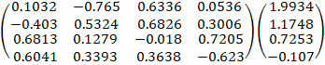 = 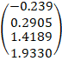
Where,
Matric F = Factor loadings obtained through the principal component analysis.
Matric E = Eigenvalues obtained through the principal component analysis.
Matric P = Product of factor loadings and eigenvalues for the four variables.
Notes:
The figures in i th row and j th column of matric F is refer to factor loading of i th variable under j th principal component. For instances,
- Weight for each variable is calculated by using the figures obtained in matric P. For instances, the weight for the first variable is calculated by dividing first figures with the sum of four figures in matric P.

Weight for variable 1 = = -0.0702

- Step 3 is repeated in order to obtain the weight of the other three variables. The method of SMPI construction is further discussed in the following section.

3.2 Index Construction
The stock market performance index (SMPI) is calculated based on the following calculation:
=
Where,
= Stock Market Performance Index of country x at year y.
= Weight assigned for variable z.
= Variable z.

4.0 RESULTS
Table 2 reported the summary statistics of the variables to be included in the SMPI construction. Stock market returns. Over the sample period year 1999 to 2016, Indonesia had the highest average stock market return and stock market volatility. The market capitalization of the domestic listed companies as a percentage of gross domestic products had been used as the proxy of stock market development. Based on table 2, Singapore had the highest average market capitalization of the domestic listed companies as a percentage of gross domestic products, with approximately 210.73 percent. Meanwhile, Singapore also had the highest average value of stocks traded as a percentage of gross domestic products, with approximately 103.64 percent.
Table 2: Summary Statistics of the Variables for SMPI construction
 | Indonesia |  | Thailand |  | Malaysia |  | Philippines |  | Singapore
 | Mean | S.D | Mean | S.D | Mean | S.D | Mean | S.D | Mean | S.D
SR | 18.62 | 34.90 | 13.05 | 37.85 | 6.13 | 19.19 | 10.66 | 29.17 | 4.54 | 26.07
SMD | 1.33 | 0.38 | 1.29 | 0.38 | 0.78 | 0.32 | 1.23 | 0.33 | 1.08 | 0.42
MCAP | 33.84 | 12.65 | 67.47 | 25.52 | 138.22 | 21.32 | 56.27 | 24.53 | 210.73 | 54.12
SML | 10.58 | 3.89 | 52.43 | 20.08 | 42.02 | 12.57 | 10.21 | 5.64 | 103.64 | 35.76
Table 3: Principal Component Analysis for Stock Market Performance Index
 | PC 1 | PC 2 | PC 3 | PC 4
SR | 0.1032 | -0.7649 | 0.6336 | 0.0536
SD | -0.4003 | 0.5324 | 0.6826 | 0.3006
MCAP | 0.6813 | 0.1279 | -0.0175 | 0.7205
SML | 0.6041 | 0.3393 | 0.3638 | -0.6226
Eigenvalue | 1.9934 | 1.1748 | 0.7253 | 0.1066
% of variance | 0.4983 | 0.2937 | 0.1813 | 0.0266
Cumulative % | 0.4983 | 0.7920 | 0.9734 | 1.0000
Notes:
PC represents principal component, SR represents stock returns of the market, SD represents the standard deviation of the market, MCAP represents market capitalization of the domestic listed companies as a percentage of gross domestic product (GDP) and SML represents value of stocks traded as a percentage of gross domestic product (GDP).
By applying the principal component analysis, both of the Eigenvector and Eigenvalue were obtained and presented in Table 3. PC 1 had the highest Eigenvalues of 1.9934, which indicated that 49.83% of the variance explained by PC 1. Meanwhile, PC 2 and PC 3 explained 29.37% and 18.13% of the variance respectively. However, PC 4 only explained 2.66% of the variance. Following the method of Chen and Woo (2010) discussed in the previous section, the weights allocated for each variable had been calculated as below:

Table 4: Weights Calculation
Variable | Figures obtained from Matric P | Weight Calculation
SR | -0.2390 | = -0.0702
SD | 0.2095 | = 0.0854
MCAP | 1.4189 | = 0.4169
SML | 1.9330 | = 0.5680
Four variables were used for the stock market performance index construction. As presented in Table 4, stock market liquidity had the highest weight for SMPI, followed by stock market development with the weight of 0.4169, stock market volatility 0.0854 and stock market return -0.0702.
Table 5: Summary Statistics of the Stock Market Performance Index (SMPI)
 | Indonesia | Thailand | Malaysia | Philippines | Singapore
Mean | 18.92 | 57.10 | 81.13 | 28.61 | 146.49
Median | 20.72 | 58.57 | 81.65 | 29.11 | 137.15
Maximum | 27.15 | 88.38 | 114.03 | 45.25 | 244.48
Minimum | 24.85 | 21.58 | 57.31 | 10.34 | 86.49
Standard deviation | 19.11 | 20.73 | 13.37 | 12.36 | 35.82
Table 5 reported the summary statistics of the Stock Market Performance Index (SMPI). Over the period from year 1999 to 2016, Singapore had the highest average SMPI of 146.49, while Indonesia had the lowest average SMPI of 18.92. In addition, Figure 2 also shown that Singapore had the highest SMPI among ASEAN 5 countries over the sample period. Noteworthy, Malaysia ranked number two over the whole sample period, however, Thailand overtake the position from the year 2015 onwards when the SMPI of Thailand exceed the SMPI of Malaysia (shown in Figure 2). Besides that, Singapore also had the biggest fluctuation in the SMPI since the standard deviation of the Singapore SMPI is the highest as compared to the other four countries.

Figure 2: Stock Market Performance Index (SMPI) over the period 1999 – 2016
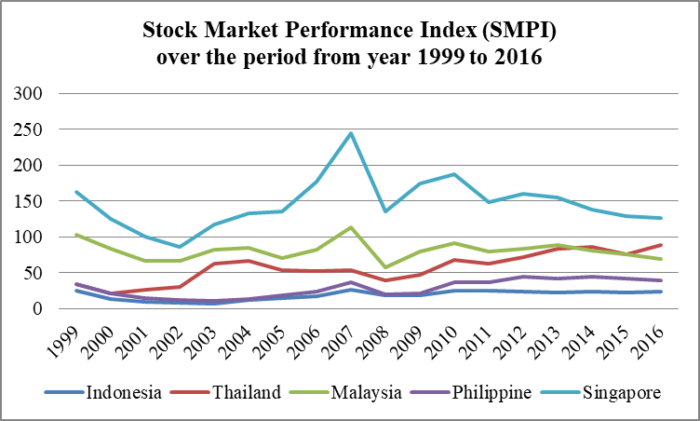
5.0 CONCLUSION
Although various types of financial indices had been developed in the previous literature, little work has been done in constructing indices that able to capture the stock market performance from different aspects. This study developed the stock market performance index (SMPI) for ASEAN-5 countries which able to capture the stock market performance from different aspects. Four variables had been used to construct SMPI and these variables were (i) stock market return, (ii) stock market volatility, (iii) stock market development and (iv) stock market liquidity. The results indicate that Singapore has the highest SMPI over the sample period from 2000 to 2016, followed by Malaysia, Thailand, Phillippines, and Indonesia.
REFERENCES
Ang, J. B., & McKibbin, W. J. (2007). Financial Liberalization, Financial Sector Development and Growth: Evidence from Malaysia. Journal of Development Economics, 84(1), 215-333.
Badeeb, R. A., & Lean, H. H. (2017). The Determinants of Financial Development in the Republic of Yemen: Evidence from the Principal Components Approach. Capital Market Review, 25(2), 32-48.
Blundell, R., & Bond, S. (1998). Initial conditions and moment restrictions in dynamic panel data models. Journal of Econometrics, 87, 115-143.
Chen, B., & Woo, Y. P. (2010). Measuring Economic Integration in the Asia-Pacic Region: A Principal Components Approach. Asian Economic Paper, 9(2), 121-143.
Dahalan, J., Abdullah, H. B., & Umar, M. (2016). Measuring Financial Stress Index for Malaysian Economy. International Journal of Economics and Financial Issues, 6(3), 942-947.
Dai, Y. H., Han, D. M., & Dai. W. H. (2014). Modeling and Computing of Stock Index Forecasting Based on Neural Network and Markov Chain. The Scientific World Journal, 2014.
Demirguc-Kunt, A., & Levine, R. (1996). Stock Market Development and Financial Intermediaries: Stylized Facts. The World Bank Economic Review, 19(2), 291-321.
Ho, S. Y., & Iyke, B. N. (2017). Determinants of Stock Market Development: A Review of the Literature. Studies in Economics and Finance, 34(1), 1-24.
Karanovic, G., & Karanovic, B. (2015). Developing An Aggregate Index for Measuring Financial Stability in the Balkans. In 7th International Conference, The Economies of Balkan and Eastern Europe Countries in the Changed World, EBEEC 2015, May 8-10 (pp.3-17).
Menon, S. (2018). A Comparative Study of the Indian Stock Market with Two International Stock Markets between 2012-17. International Journal of Engineering Technology Science and Research, 5(3), 446-459.
Morales, M. A., & Estrada, D. (2010). A Financial Stability Index for Colombia. Annals of Finance, 6(4), 555-581.
Naseer, F. A. M., Rosid, C. M. A. C., & Baharuddin, N. S. (2017). Relation between Macroeconomic Variables and ASEAN Stock Index. Terengganu International Finance and Economics Journal, 5(1), 7-13.
Osei, V. (2005). Does the Stock Market Matter in Ghana? A Granger-Causality Analysis (Working Paper). Retrieved from Bank of Ghana
Pan, L., & Mishra, V. (2016). Stock Market Development and Economic Growth: Empirical Evidence from China. Economic Modelling, 68, 661-673.
Qiu, M. Y., & Song, Y. (2016). Predicting the Direction of Stock Market Index Movement Using an Optimized Artificial Neural Network Model. PLoS ONE, 11(5), 1-11. https: doi:10.1371/journal.pone.0155133.
Soedarmono, W. (2018). Stock Market Integration in the Asia Pacific Region: Evidence from Cointegration of Liquidity Risk. Economic Bulletin, 38(1), 60-70.
Yamamoto, S. (2012). Association of Southeast Asian Nations. In George. R (1st Edition), The Wiley-Blackwell Encyclopedia of Globalization.
Yorulmaz, R. (2013). Construction of a Regional Financial Inclusion Index in Turkey. Journal of BRSA Banking and Financial Markets, 7(1), 79-101.

